The Red Sea 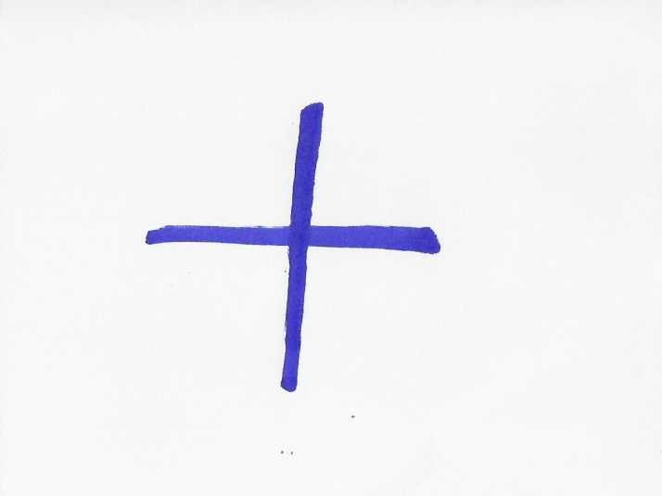
Grouping: A.1, A.2  (individual) and A.3 (whole class)

Worksheet 3
- 1 Read the name “Red Sea” in Latin, Greek, Arabic and Hebrew. All these languages belong to people who live or had lived in the broader area where the Red Sea is located and have had close contact with this sea. (In the brackets you can see the original writing in the alphabet of the languages that do not use the Latin letters. The bold letters indicate where the stress is. Source: http://en.wikipedia.org/wiki/Red_Sea):
Greek Erythra Thalassa (Ερυθρά Θάλασσα),
Latin Mare Rubrum
Arabic Al-Bahr Al-Ahmar (البحر الأحمر)
Hebrew Hayam ha-adom (הים האדום)
- Using the information in Worksheet 2 and in this worksheet try to fill in the table below:
Language | Red | Sea
Greek
Latin
Arabic |  | Al-Bahr
Hebrew | ha-adom
3. Check your answers of Task 1 and Task 2 with those of your fellow students.

